**Tutorial Membuat Aplikasi dengan CI**

1. Download CI di situs codeigniter <https://codeigniter.com/download>.
2. Ekstrak CI hasil download kemudian Rename Aplikasi CI yg didownload tdi dengan nama **aplikasi_c**i dan simpan pada folder xampp/htdocs. 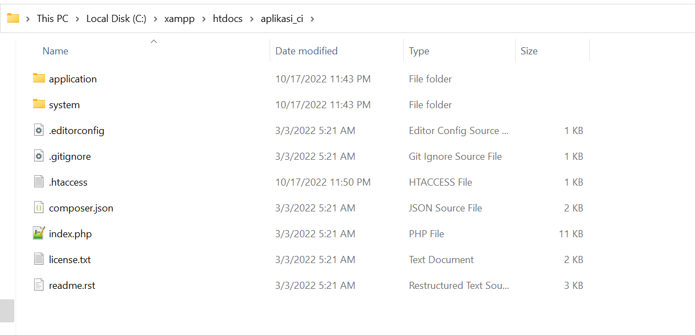
3. Uji coba menjalankan aplikasi_ci pada browser
4. 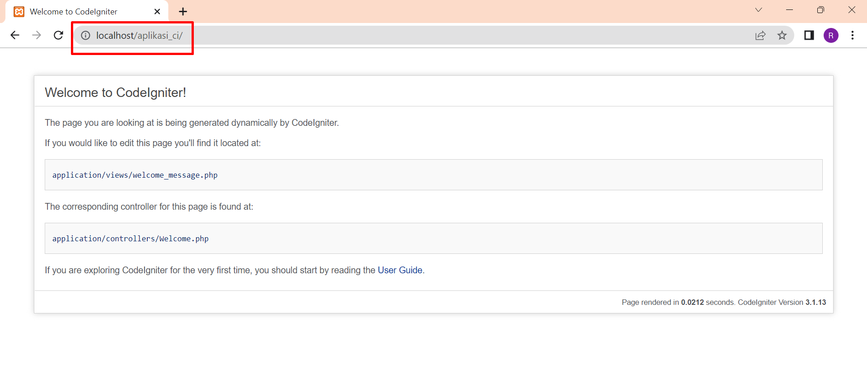
5. Buat Database Buat database dengan nama **sekolah**, kemudian buat tabel bernama **siswa** dengan klik New -> SQL. 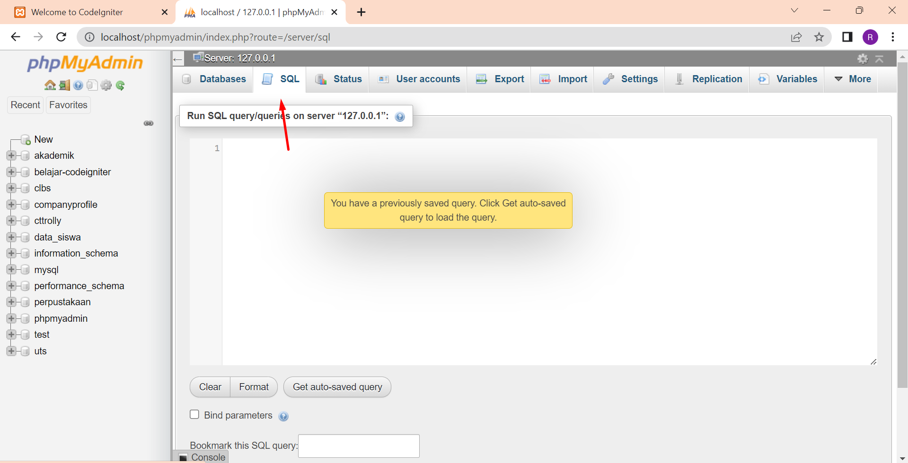
6. Inputkan Coding berikut:

CREATE DATABASE sekolah;

USE sekolah;

CREATE TABLE siswa (

Id_siswa int(11) NOT NULL PRIMARY KEY AUTO_INCREMENT,

Nama varchar(150),

JenisKelamin varchar(20),

Alamat text,

Agama varchar(30),

NoHp varchar(15),

Email varchar(150)

);

1. 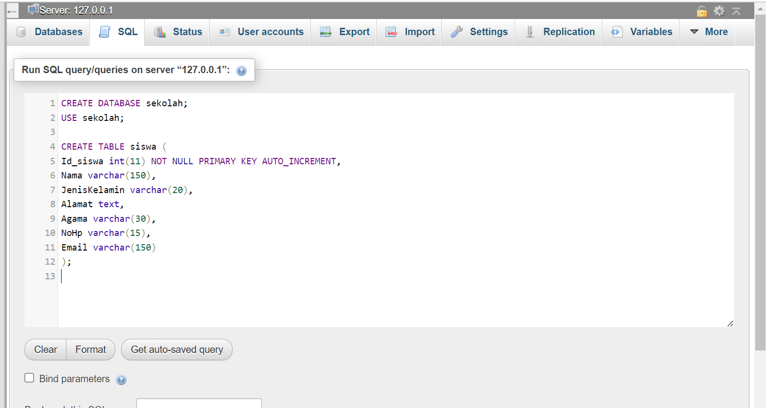
2. Konfigurasi Codeigniter
3. Silahkan buka **config/database.php**, isikan seperti dibawah ini: 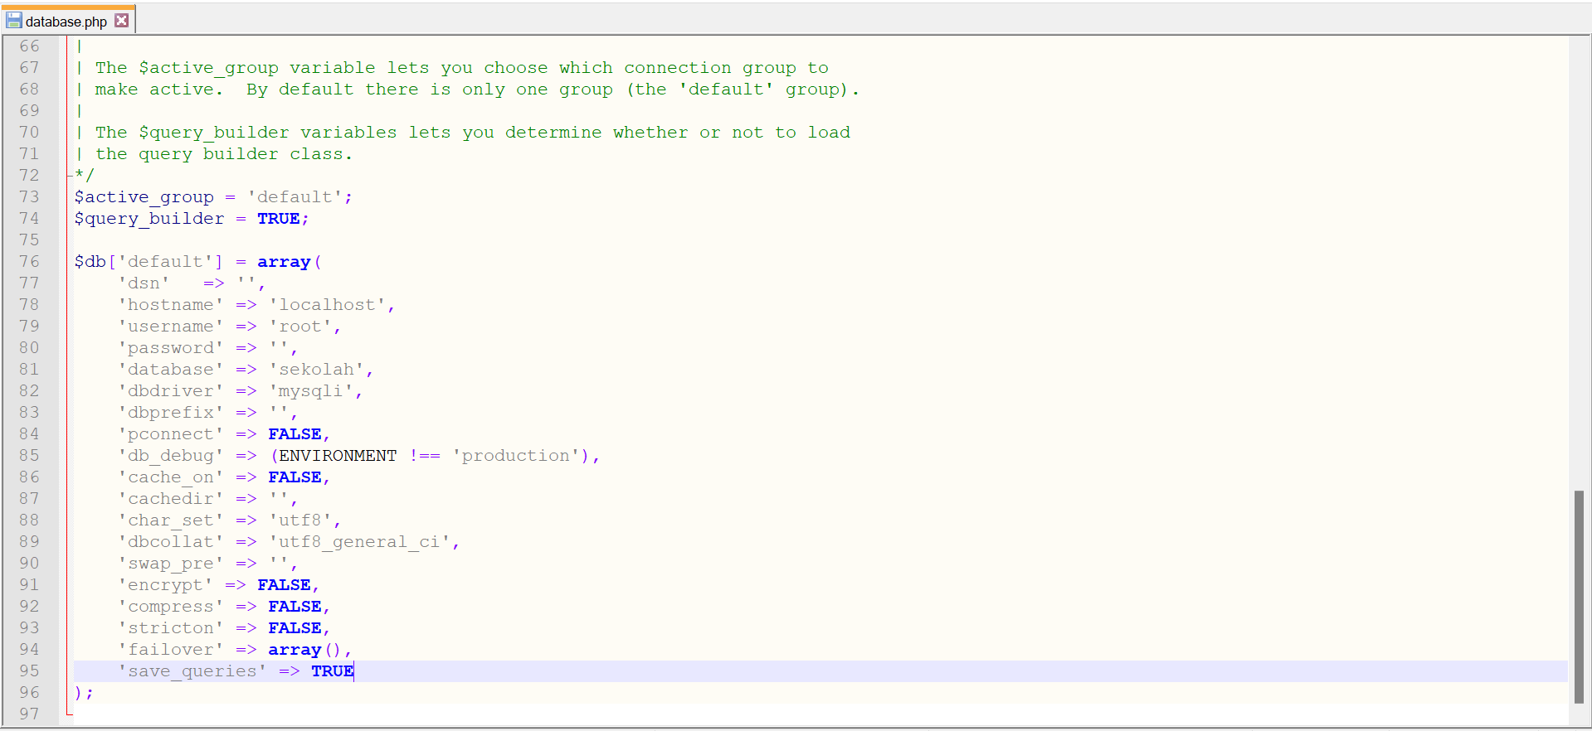
4. Buka config/config.php, Cari kode $config['base_url'] = ''; ubah kode menjadi seperti ini $config['base_url'] = 'http://localhost:/aplikasi_ci/'; Kemudian cari kode $config['index_page'] = 'index.php'; ubah menjadi $config['index_page'] = ''; 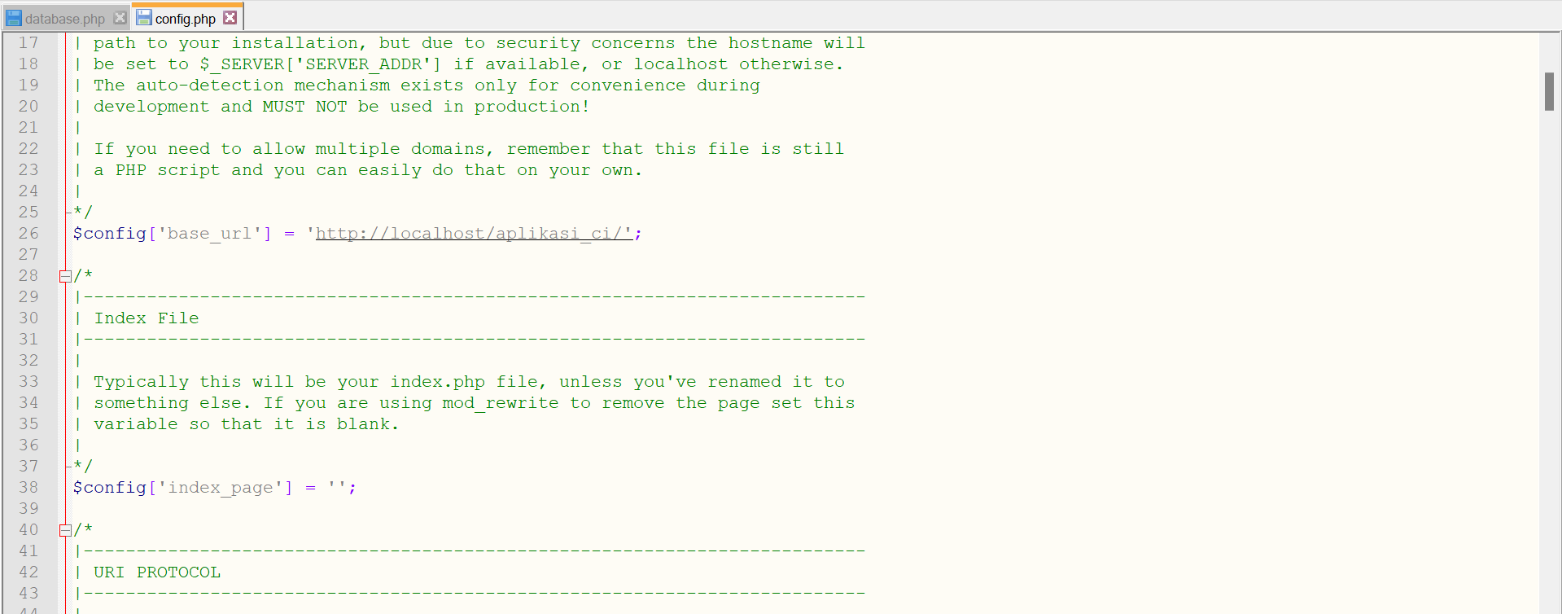
5. Buka **config/autoload.php**, cari libraries dan helper kemudian isikan seperti ini. 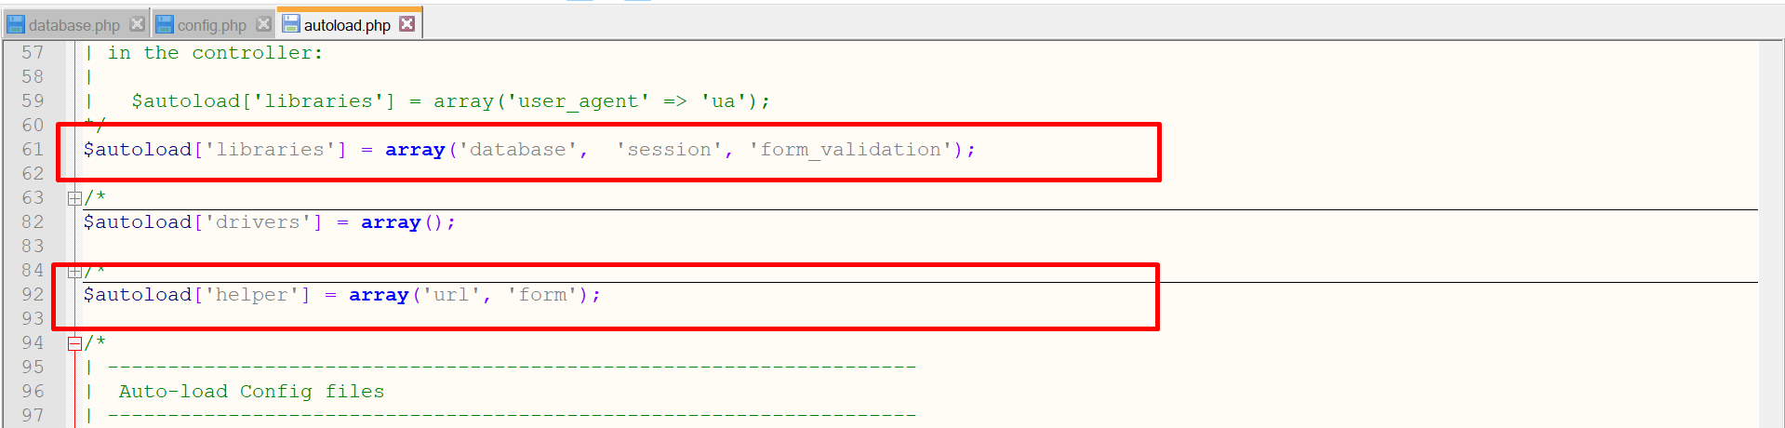
6. Keterangan Load library Database untuk menyediakan fungsi-fungsi operasi database.

Session untuk menyediakan fungsi-fungsi session dan menampilkan flash message.

Form validation untuk menyediakan fungsi-fungsi validasi kolom inputan.

Helper url digunakan untuk bekerja dengan URL.

Helper form digunakan untuk bekerja dengan Form.

1. Buka **config/routes.php**. Ubah default controler menjadi seperti ini: 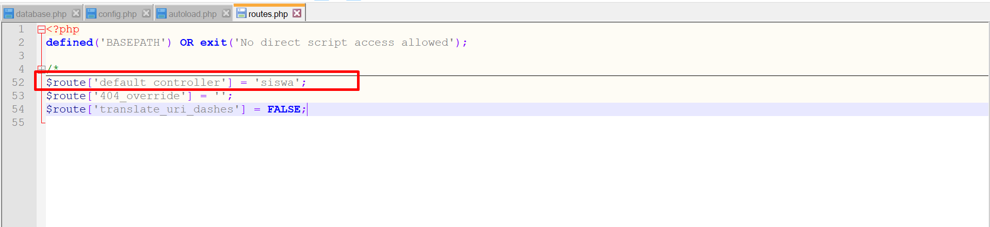
2. Membuat htaccess

buat file baru pada folder **aplikasi_ci**, Copykan script dibawah ini kemudian simpan dengan nama .htaccess

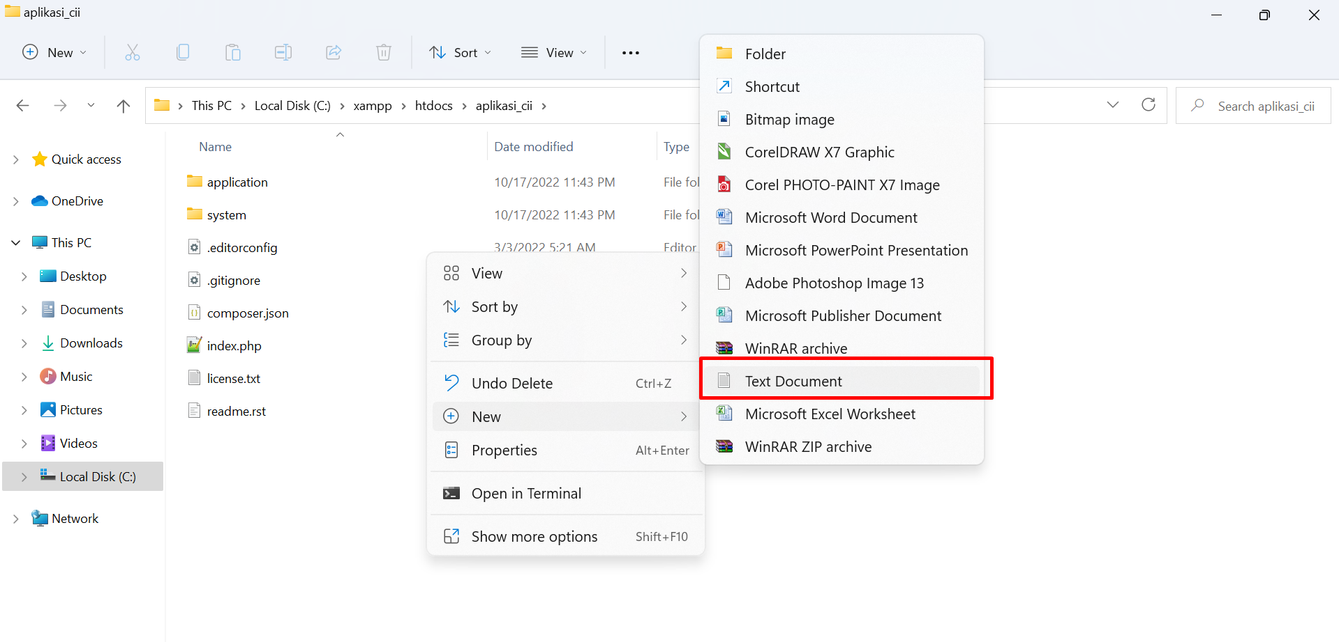

Scrip:

RewriteEngine On

RewriteCond %{REQUEST_FILENAME} !-f

RewriteCond %{REQUEST_FILENAME} !-d

RewriteRule ^(.*)$ index.php/$1 [L]

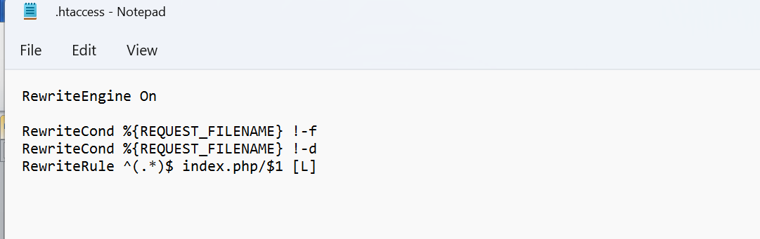

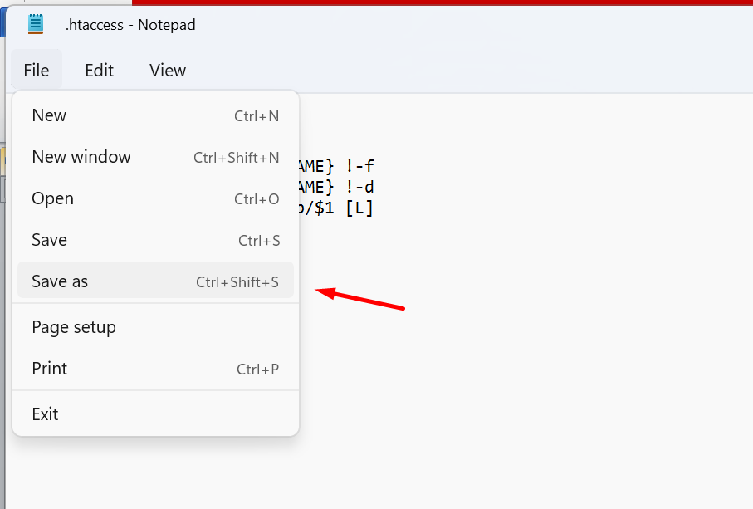

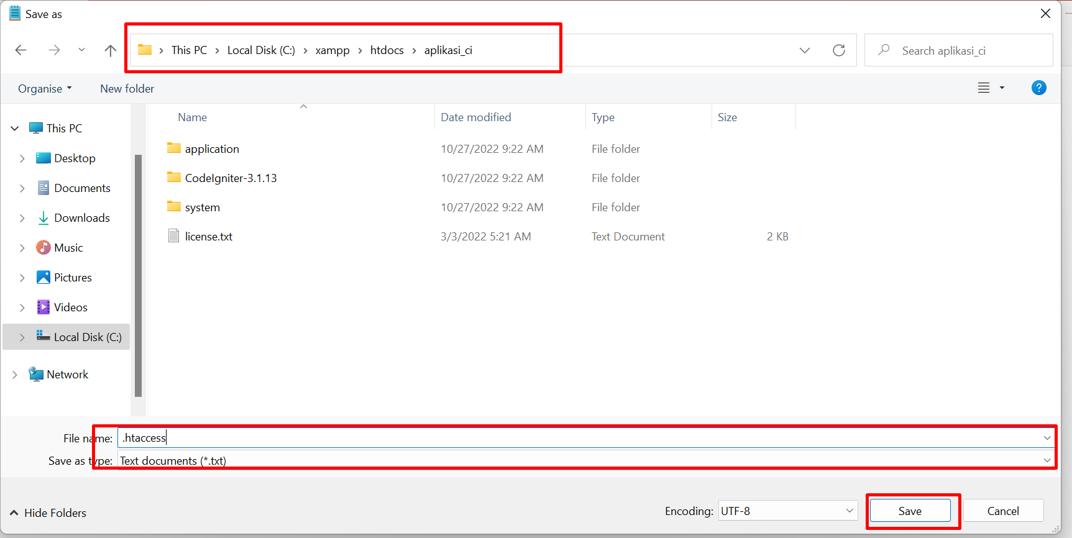 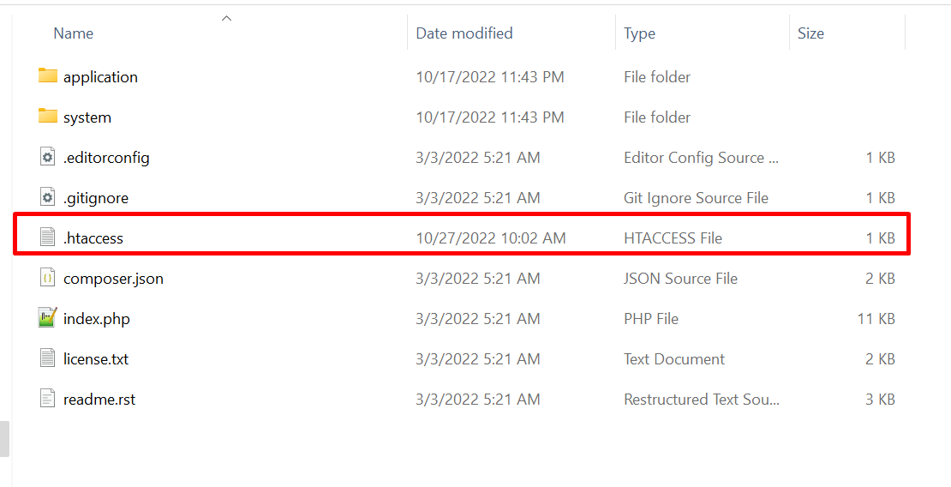

1. Buat Model Model berisi fungsi-fungsi query mysql untuk menampilkan semua data siswa, data siswa berdasarkan id, simpan data, edit data dan hapus dataSiswa. Buat file Siswa_model.php pada folder models. 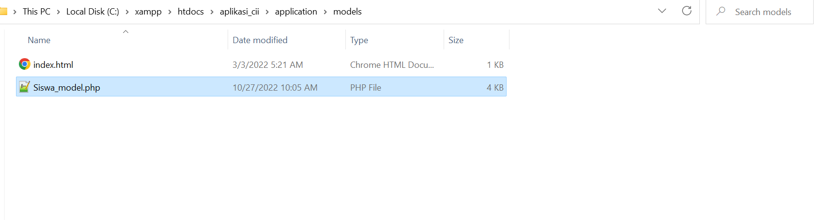

Coding nya:

<?php

**defined**('BASEPATH') **or** **exit**('No direct script access allowed');

**class** Siswa_model **extends** CI_Model

{

**private** $table = 'Siswa';

//validasi form, method ini akan mengembailkan data berupa rules validasi form

**public** **function** rules()

{

**return** [

[

'field' => 'Nama', //samakan dengan atribute name pada tags input

'label' => 'Nama', // label yang kan ditampilkan pada pesan error

'rules' => 'trim|required' //rules validasi

],

[

'field' => 'JenisKelamin',

'label' => 'Jenis Kelamin',

'rules' => 'trim|required'

],

[

'field' => 'Alamat',

'label' => 'Alamat',

'rules' => 'trim|required'

],

[

'field' => 'Agama',

'label' => 'Agama',

'rules' => 'trim|required'

],

[

'field' => 'NoHp',

'label' => 'No Hp',

'rules' => 'trim|required|numeric|min_length[9]|max_length[15]'

],

[

'field' => 'Email',

'label' => 'Email',

'rules' => 'trim|required'

]

];

}

//menampilkan data siswa berdasarkan id siswa

**public** **function** getById($id)

{

**return** $this->db->get_where($this->table, ["Id_siswa" => $id])->row();

//query diatas seperti halnya query pada mysql

//select * from siswa where Id_siswa='$id'

}

//menampilkan semua data Siswa

**public** **function** getAll()

{

$this->db->from($this->table);

$this->db->order_by("Id_siswa", "desc");

$query = $this->db->get();

**return** $query->result();

//fungsi diatas seperti halnya query

//select * from siswa order by Id_siswa desc

}

//menyimpan data siswa

**public** **function** save()

{

$data = **array**(

"Nama" => $this->input->post('Nama'),

"JenisKelamin" => $this->input->post('JenisKelamin'),

"Alamat" => $this->input->post('Alamat'),

"Agama" => $this->input->post('Agama'),

"NoHp" => $this->input->post('NoHp'),

"Email" => $this->input->post('Email')

);

**return** $this->db->insert($this->table, $data);

}

//edit data siswa

**public** **function** update()

{

$data = **array**(

"Nama" => $this->input->post('Nama'),

"JenisKelamin" => $this->input->post('JenisKelamin'),

"Alamat" => $this->input->post('Alamat'),

"Agama" => $this->input->post('Agama'),

"NoHp" => $this->input->post('NoHp'),

"Email" => $this->input->post('Email')

);

**return** $this->db->update($this->table, $data, **array**('Id_siswa' => $this->input->post('Id_siswa')));

}

//hapus data siswa

**public** **function** **delete**($id)

{

**return** $this->db->**delete**($this->table, **array**("Id_siswa" => $id));

}

}

1. Nama model diawali dengan huruf kapital yaitu Siswa_model.php, sedangkan nama class samakan dengan nama file. Siswa_model.php akan di load pada controllers Siswa.php untuk di eksekusi. Untuk jenisjenis validasi pada form Anda dapat membaca pada dokumentasi Codeigniter.
2. Buat Controller digunakan untuk menghubungkan antara model dengan view. Buat file Siswa.php pada folder controllers. Nama file diawali dengan huruf kapital. 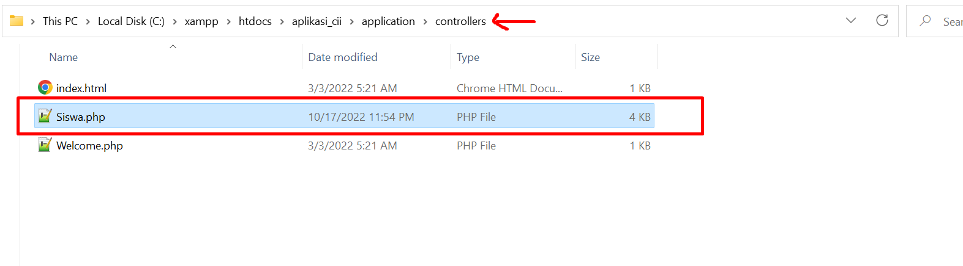

Coding:

<?php

**defined**('BASEPATH') **or** **exit**('No direct script access allowed');

**class** Siswa **extends** CI_Controller

{

**public** **function** **__construct**()

{

**parent**::**__construct**();

$this->load->model("Siswa_model"); //load model Siswa

}

//method pertama yang akan di eksekusi

**public** **function** index()

{

$data["title"] = "List Data Siswa";

//ambil fungsi getAll untuk menampilkan semua data Siswa

$data["data_siswa"] = $this->Siswa_model->getAll();

//load view header.php pada folder views/templates

$this->load->view('templates/header', $data);

$this->load->view('templates/menu');

//load view index.php pada folder views/Siswa

$this->load->view('siswa/index', $data);

$this->load->view('templates/footer');

}

//method add digunakan untuk menampilkan form tambah data Siswa

**public** **function** add()

{

$Siswa = $this->Siswa_model; //objek model

$validation = $this->form_validation; //objek form validation

$validation->set_rules($Siswa->rules()); //menerapkan rules validasi pada Siswa_model

//kondisi jika semua kolom telah divalidasi, maka akan menjalankan method save pada Siswa_model

**if** ($validation->run()) {

$Siswa->save();

$this->session->set_flashdata('message', '<div class="alert alert-success alert-dismissible fade show" role="alert">

Data Siswa berhasil disimpan.

<button type="button" class="close" data-dismiss="alert" aria-label="Close">

<span aria-hidden="true">&times;</span>

</button></div>');

redirect("Siswa");

}

$data["title"] = "Tambah Data Siswa";

$this->load->view('templates/header', $data);

$this->load->view('templates/menu');

$this->load->view('Siswa/add', $data);

$this->load->view('templates/footer');

}

**public** **function** edit($id = **null**)

{

**if** (!**isset**($id)) redirect('Siswa');

$Siswa = $this->Siswa_model;

$validation = $this->form_validation;

$validation->set_rules($Siswa->rules());

**if** ($validation->run()) {

$Siswa->update();

$this->session->set_flashdata('message', '<div class="alert alert-success alert-dismissible fade show" role="alert">

Data Siswa berhasil disimpan.

<button type="button" class="close" data-dismiss="alert" aria-label="Close">

<span aria-hidden="true">&times;</span>

</button></div>');

redirect("Siswa");

}

$data["title"] = "Edit Data Siswa";

$data["data_Siswa"] = $Siswa->getById($id);

**if** (!$data["data_Siswa"]) show_404();

$this->load->view('templates/header', $data);

$this->load->view('templates/menu');

$this->load->view('siswa/edit', $data);

$this->load->view('templates/footer');

}

**public** **function** **delete**()

{

$id = $this->input->get('id');

**if** (!**isset**($id)) show_404();

$this->Siswa_model->**delete**($id);

$msg['success'] = **true**;

$this->session->set_flashdata('message', '<div class="alert alert-success alert-dismissible fade show" role="alert">

Data Siswa berhasil dihapus.

<button type="button" class="close" data-dismiss="alert" aria-label="Close">

<span aria-hidden="true">&times;</span>

</button></div>');

$this->output->set_output(**json_encode**($msg));

}

}

1. Buat View Setelah controller siswa dibuat selanjutkan kita akan membuat view untuk menampilkan data siswa. Disini saya membagi view menjadi beberapa bagian. Pada folder views/template, kita akan menyimpan file view header, menu dan footer. Kemudian pada folder views/siswa berisi view untuk menampikan semua data, view form add dan view form edit.
2. Buat 2 folder di dalam views yaitu siswa dan templates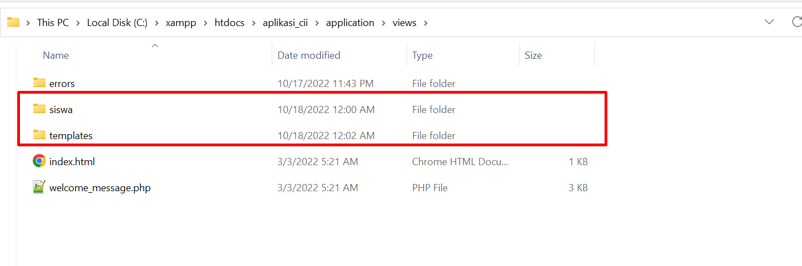
3. Didalam Views/templates buat file **header.php**, kemudian isikan kode seperti berikut ini:

<!DOCTYPE html>

<html lang=**"en"**>

<head>

<title><?= $title ?></title>

<meta charset=**"utf-8"**>

<meta name=**"viewport"** content=**"width=device-width, initial-scale=1"**>

<!-- Bootstrap 4.5.2-->

<link rel=**"stylesheet"** href=**"https://maxcdn.bootstrapcdn.com/bootstrap/4.5.2/css/bootstrap.min.css"**>

<!-- Fontawesome 5.15.3-->

<link rel=**"stylesheet"** href=**"https://cdnjs.cloudflare.com/ajax/libs/font-awesome/5.15.3/css/all.min.css"** integrity=**"sha512-iBBXm8fW90+nuLcSKlbmrPcLa0OT92xO1BIsZ+ywDWZCvqsWgccV3gFoRBv0z+8dLJgyAHIhR35VZc2oM/gI1w=="** crossorigin=**"anonymous"** referrerpolicy=**"no-referrer"** />

<!-- Datatables -->

<link rel=**"stylesheet"** href=**"https://cdn.datatables.net/1.10.24/css/dataTables.bootstrap4.min.css"**>

<script src=**"https://ajax.googleapis.com/ajax/libs/jquery/3.5.1/jquery.min.js"**></script>

<script src=**"https://cdnjs.cloudflare.com/ajax/libs/popper.js/1.16.0/umd/popper.min.js"**></script>

<script src=**"https://maxcdn.bootstrapcdn.com/bootstrap/4.5.2/js/bootstrap.min.js"**></script>

<script src=**"https://cdnjs.cloudflare.com/ajax/libs/font-awesome/5.15.3/js/all.min.js"** integrity=**"sha512-RXf+QSDCUQs5uwRKaDoXt55jygZZm2V++WUZduaU/Ui/9EGp3f/2KZVahFZBKGH0s774sd3HmrhUy+SgOFQLVQ=="** crossorigin=**"anonymous"** referrerpolicy=**"no-referrer"**></script>

<script src=**"https://cdn.datatables.net/1.10.24/js/jquery.dataTables.min.js"**></script>

<script src=**"https://cdn.datatables.net/1.10.24/js/dataTables.bootstrap4.min.js"**></script>

</head>

<body>

1. Didalam Views/templates buat file menu.php, kemudian isikan kode seperti berikut ini:

<nav class=**"navbar navbar-expand-md bg-dark navbar-dark"**>

<!-- Brand -->

<a class=**"navbar-brand"** href=**"#"**>**Aplikasi CI**</a>

<!-- Toggler/collapsibe Button -->

<button class=**"navbar-toggler"** type=**"button"** data-toggle=**"collapse"** data-target=**"#collapsibleNavbar"**>

<span class=**"navbar-toggler-icon"**></span>

</button>

<!-- Navbar links -->

<div class=**"collapse navbar-collapse"** id=**"collapsibleNavbar"**>

<ul class=**"navbar-nav"**>

<li class=**"nav-item active"**>

<a class=**"nav-link"** href=**"**<?= base_url('siswa'); ?>**"**>**Siswa**</a>

</li>

<li class=**"nav-item"**>

<a class=**"nav-link"** href=**"#"**>**Link**</a>

</li>

</ul>

</div>

</nav>

1. Didalam Views/templates buat file footer.php, kemudian isikan kode seperti berikut ini:

</body>

</html>

1. Jadi hasil didalamnya akan seperti ini:

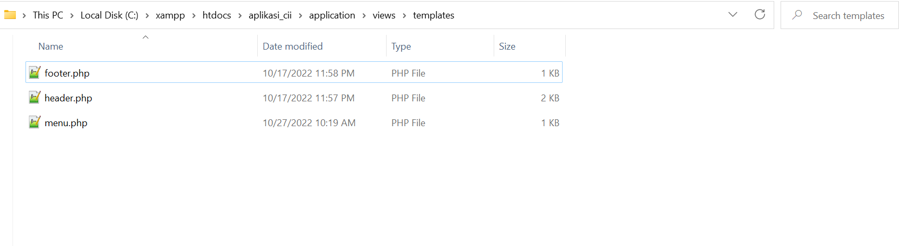

1. Didalam Views/Siswa buat file **index.php**, kemudian isikan kode seperti berikut ini:

<div class=**"container pt-5"**>

<h3><?= $title ?></h3>

<nav aria-label=**"breadcrumb"**>

<ol class=**"breadcrumb "**>

<li class=**"breadcrumb-item"**><a>**Siswa**</a></li>

<li class=**"breadcrumb-item active"** aria-current=**"page"**>**List Data**</li>

</ol>

</nav>

<div class=**"row"**>

<div class=**"col-md-12"**>

<a class=**"btn btn-primary mb-2"** href=**"**<?= base_url('siswa/add'); ?>**"**>**Tambah Data**</a>

<div mb-2>

<!-- Menampilkan flashh data (pesan saat data berhasil disimpan)-->

<?php **if** ($this->session->flashdata('message')) :

**echo** $this->session->flashdata('message');

**endif**; ?>

</div>

<div class=**"card"**>

<div class=**"card-body"**>

<div class=**"table-responsive"**>

<table class=**"table table-striped table-bordered table-hover"** id=**"tablesiswa"**>

<thead>

<tr class=**"table-success"**>

<th></th>

<th>**NAMA**</th>

<th>**JENIS KELAMIN**</th>

<th>**ALAMAT**</th>

<th>**AGAMA**</th>

<th>**NO HP**</th>

<th>**EMAIL**</th>

</tr>

</thead>

<tbody>

<?php **foreach** ($data_siswa **as** $row) : ?>

<tr>

<td>

<a href=**"**<?= site_url('siswa/edit/' . $row->Id_siswa) ?>**"** class=**"btn btn-success btn-sm"**><i class=**"fa fa-edit"**></i></a>

<a href=**"javascript:void(0);"** data=**"**<?= $row->Id_siswa ?>**"** class=**"btn btn-danger btn-sm item-delete"**><i class=**"fa fa-trash"**></i></a>

</td>

<td><?= $row->Nama ?></td>

<td><?= $row->JenisKelamin ?></td>

<td><?= $row->Alamat ?></td>

<td><?= $row->Agama ?></td>

<td><?= $row->NoHp ?></td>

<td><?= $row->Email ?></td>

</tr>

<?php **endforeach**; ?>

</tbody>

</table>

</div>

</div>

</div>

</div>

</div>

</div>

<!-- Modal dialog hapus data-->

<div class=**"modal fade"** id=**"myModalDelete"** tabindex=**"-1"** aria-labelledby=**"myModalDeleteLabel"** aria-hidden=**"true"**>

<div class=**"modal-dialog"**>

<div class=**"modal-content"**>

<div class=**"modal-header"**>

<h5 class=**"modal-title"** id=**"myModalDeleteLabel"**>**Konfirmasi**</h5>

<button type=**"button"** class=**"close"** data-dismiss=**"modal"** aria-label=**"Close"**>

<span aria-hidden=**"true"**>*&times;*</span>

</button>

</div>

<div class=**"modal-body"**>

**Anda ingin menghapus data ini?**

</div>

<div class=**"modal-footer"**>

<button type=**"button"** class=**"btn btn-secondary"** data-dismiss=**"modal"**>**Tutup**</button>

<button type=**"button"** class=**"btn btn-danger"** id=**"btdelete"**>**Lanjutkan**</button>

</div>

</div>

</div>

</div>

<script>

//menampilkan data ketabel dengan plugin datatables

$**(**'#tablesiswa'**).**DataTable**();**

//menampilkan modal dialog saat tombol hapus ditekan

$**(**'#tablesiswa'**).**on**(**'click'**,** '.item-delete'**,** ***function*()** **{**

//ambil data dari atribute data

***var*** id **=** $**(*this*).**attr**(**'data'**);**

$**(**'#myModalDelete'**).**modal**(**'show'**);**

//ketika tombol lanjutkan ditekan, data id akan dikirim ke method delete

//pada controller siswa

$**(**'#btdelete'**).**unbind**().**click**(*function*()** **{**

$**.**ajax**({**

type**:** 'ajax'**,**

method**:** 'get'**,**

***async*:** ***false*,**

url**:** '<?php echo base_url() ?>siswa/delete/'**,**

data**:** **{**

id**:** id

**},**

dataType**:** 'json'**,**

success**:** ***function*(**response**)** **{**

$**(**'#myModalDelete'**).**modal**(**'hide'**);**

location.reload**();**

**}**

**});**

**});**

**});**

</script>

1. Didalam Views/Siswa buat file **add.php**, kemudian isikan kode seperti berikut ini:

<div class=**"container pt-5"**>

<h3><?= $title ?></h3>

<nav aria-label=**"breadcrumb"**>

<ol class=**"breadcrumb "**>

<li class=**"breadcrumb-item"**><a>**Siswa**</a></li>

<li class=**"breadcrumb-item "**><a href=**"**<?= base_url('siswa'); ?>**"**>**List Data**</a></li>

<li class=**"breadcrumb-item active"** aria-current=**"page"**>**Add Data**</li>

</ol>

</nav>

<div class=**"row"**>

<div class=**"col-md-12"**>

<div class=**"card"**>

<div class=**"card-body"**>

<?php

//create form

$attributes = **array**('id' => 'FrmAddsiswa', 'method' => "post", "autocomplete" => "off");

**echo** form_open('', $attributes);

?>

<div class=**"form-group row"**>

<label for=**"Nama"** class=**"col-sm-2 col-form-label"**>**Nama**</label>

<div class=**"col-sm-10"**>

<input type=**"text"** class=**"form-control"** id=**"Nama"** name=**"Nama"** value=**"** <?= set_value('Nama'); ?>**"**>

<small class=**"text-danger"**>

<?php **echo** form_error('Nama') ?>

</small>

</div>

</div>

<fieldset class=**"form-group"**>

<div class=**"row"**>

<legend class=**"col-form-label col-sm-2 pt-0"**>**Jenis Kelamin**</legend>

<div class=**"col-sm-10"**>

<div class=**"form-check form-check-inline"**>

<input class=**"form-check-input"** type=**"radio"** id=**"JenisKelamin"** name=**"JenisKelamin"** value=**"Laki-laki"** <?php **if** (set_value('JenisKelamin') == "Laki-laki") : **echo** "checked";

**endif**; ?>>

<label class=**"form-check-label"** for=**"JenisKelamin"**>

**Laki-laki**

</label>

</div>

<div class=**"form-check form-check-inline"**>

<input class=**"form-check-input"** type=**"radio"** id=**"JenisKelamin2"** name=**"JenisKelamin"** value=**"Perempuan"** <?php **if** (set_value('JenisKelamin') == "Perempuan") : **echo** "checked";

**endif**; ?>>

<label class=**"form-check-label"** for=**"JenisKelamin2"**>

**Perempuan**

</label>

</div>

<small class=**"text-danger"**>

<?php **echo** form_error('JenisKelamin') ?>

</small>

</div>

</div>

</fieldset>

<div class=**"form-group row"**>

<label for=**"Alamat"** class=**"col-sm-2 col-form-label"**>**Alamat**</label>

<div class=**"col-sm-10"**>

<textarea class=**"form-control"** id=**"Alamat"** name=**"Alamat"** rows=**"3"**><?= set_value('Alamat'); ?></textarea>

<small class=**"text-danger"**>

<?php **echo** form_error('Alamat') ?>

</small>

</div>

</div>

<div class=**"form-group row"**>

<label for=**"Alamat"** class=**"col-sm-2 col-form-label"**>**Agama**</label>

<div class=**"col-sm-10"**>

<select class=**"form-control"** id=**"Agama"** name=**"Agama"**>

<option value=**"Islam"** selected disabled>**Pilih**</option>

<option value=**"Islam"** <?php **if** (set_value('Agama') == "Islam") : **echo** "selected";

**endif**; ?>>**Islam**</option>

<option value=**"Protestan"** <?php **if** (set_value('Agama') == "Protestan") : **echo** "selected";

**endif**; ?>>**Protestan**</option>

<option value=**"Katolik"** <?php **if** (set_value('Agama') == "Katolik") : **echo** "selected";

**endif**; ?>>**Katolik**</option>

<option value=**"Hindu"** <?php **if** (set_value('Agama') == "Hindu") : **echo** "selected";

**endif**; ?>>**Hindu**</option>

<option value=**"Buddha"** <?php **if** (set_value('Agama') == "Buddha") : **echo** "selected";

**endif**; ?>>**Buddha**</option>

<option value=**"Khonghucu"** <?php **if** (set_value('Agama') == "Khonghucu") : **echo** "selected";

**endif**; ?>>**Khonghucu**</option>

</select>

<small class=**"text-danger"**>

<?php **echo** form_error('Agama') ?>

</small>

</div>

</div>

<div class=**"form-group row"**>

<label for=**"NoHp"** class=**"col-sm-2 col-form-label"**>**No Hp**</label>

<div class=**"col-sm-5"**>

<input type=**"text"** class=**"form-control"** id=**"NoHp"** name=**"NoHp"** value=**"**<?= set_value('NoHp'); ?>**"**>

<small class=**"text-danger"**>

<?php **echo** form_error('NoHp') ?>

</small>

</div>

</div>

<div class=**"form-group row"**>

<label for=**"Email"** class=**"col-sm-2 col-form-label"**>**Email**</label>

<div class=**"col-sm-8"**>

<input type=**"text"** class=**"form-control"** id=**"Email"** name=**"Email"** value=**"**<?= set_value('Email'); ?>**"**>

<small class=**"text-danger"**>

<?php **echo** form_error('Email') ?>

</small>

</div>

</div>

<div class=**"form-group row"**>

<div class=**"col-sm-10 offset-md-2"**>

<button type=**"submit"** class=**"btn btn-primary"**>**Simpan**</button>

<a class=**"btn btn-secondary"** href=**"javascript:history.back()"**>**Kembali**</a>

</div>

</div>

</form>

</div>

</div>

</div>

</div>

</div>

1. Didalam Views/Siswa buat file edit.php, kemudian isikan kode seperti berikut ini:

<div class=**"container pt-5"**>

<h3><?= $title ?></h3>

<nav aria-label=**"breadcrumb"**>

<ol class=**"breadcrumb "**>

<li class=**"breadcrumb-item"**><a>**Siswa**</a></li>

<li class=**"breadcrumb-item "**><a href=**"**<?= base_url('siswa'); ?>**"**>**List Data**</a></li>

<li class=**"breadcrumb-item active"** aria-current=**"page"**>**Edit Data**</li>

</ol>

</nav>

<div class=**"row"**>

<div class=**"col-md-12"**>

<div class=**"card"**>

<div class=**"card-body"**>

<?php

//create form

$attributes = **array**('id' => 'FrmEditsiswa', 'method' => "post", "autocomplete" => "off");

**echo** form_open('', $attributes);

?>

<div class=**"form-group row"**>

<label for=**"Nama"** class=**"col-sm-2 col-form-label"**>**Nama**</label>

<div class=**"col-sm-10"**>

<input type=**"hidden"** class=**"form-control"** id=**"Id_siswa"** name=**"Id_siswa"** value=**"** <?= $data_Siswa->Id_siswa; ?>**"**>

<input type=**"text"** class=**"form-control"** id=**"Nama"** name=**"Nama"** value=**"** <?= $data_Siswa->Nama; ?>**"**>

<small class=**"text-danger"**>

<?php **echo** form_error('Nama') ?>

</small>

</div>

</div>

<fieldset class=**"form-group"**>

<div class=**"row"**>

<legend class=**"col-form-label col-sm-2 pt-0"**>**Jenis Kelamin**</legend>

<div class=**"col-sm-10"**>

<div class=**"form-check form-check-inline"**>

<input class=**"form-check-input"** type=**"radio"** id=**"JenisKelamin"** name=**"JenisKelamin"** value=**"Laki-laki"** <?php **if** ($data_Siswa->JenisKelamin == "Laki-laki") : **echo** "checked";

**endif**; ?>>

<label class=**"form-check-label"** for=**"JenisKelamin"**>

**Laki-laki**

</label>

</div>

<div class=**"form-check form-check-inline"**>

<input class=**"form-check-input"** type=**"radio"** id=**"JenisKelamin2"** name=**"JenisKelamin"** value=**"Perempuan"** <?php **if** ($data_Siswa->JenisKelamin == "Perempuan") : **echo** "checked";

**endif**; ?>>

<label class=**"form-check-label"** for=**"JenisKelamin2"**>

**Perempuan**

</label>

</div>

<small class=**"text-danger"**>

<?php **echo** form_error('JenisKelamin') ?>

</small>

</div>

</div>

</fieldset>

<div class=**"form-group row"**>

<label for=**"Alamat"** class=**"col-sm-2 col-form-label"**>**Alamat**</label>

<div class=**"col-sm-10"**>

<textarea class=**"form-control"** id=**"Alamat"** name=**"Alamat"** rows=**"3"**><?= $data_Siswa->Alamat; ?></textarea>

<small class=**"text-danger"**>

<?php **echo** form_error('Alamat') ?>

</small>

</div>

</div>

<div class=**"form-group row"**>

<label for=**"Alamat"** class=**"col-sm-2 col-form-label"**>**Agama**</label>

<div class=**"col-sm-10"**>

<select class=**"form-control"** id=**"Agama"** name=**"Agama"**>

<option value=**"Islam"** selected disabled>**Pilih**</option>

<option value=**"Islam"** <?php **if** ($data_Siswa->Agama == "Islam") : **echo** "selected";

**endif**; ?>>**Islam**</option>

<option value=**"Protestan"** <?php **if** ($data_Siswa->Agama == "Protestan") : **echo** "selected";

**endif**; ?>>**Protestan**</option>

<option value=**"Katolik"** <?php **if** ($data_Siswa->Agama == "Katolik") : **echo** "selected";

**endif**; ?>>**Katolik**</option>

<option value=**"Hindu"** <?php **if** ($data_Siswa->Agama == "Hindu") : **echo** "selected";

**endif**; ?>>**Hindu**</option>

<option value=**"Buddha"** <?php **if** ($data_Siswa->Agama == "Buddha") : **echo** "selected";

**endif**; ?>>**Buddha**</option>

<option value=**"Khonghucu"** <?php **if** ($data_Siswa->Agama == "Khonghucu") : **echo** "selected";

**endif**; ?>>**Khonghucu**</option>

</select>

<small class=**"text-danger"**>

<?php **echo** form_error('Agama') ?>

</small>

</div>

</div>

<div class=**"form-group row"**>

<label for=**"NoHp"** class=**"col-sm-2 col-form-label"**>**No Hp**</label>

<div class=**"col-sm-5"**>

<input type=**"text"** class=**"form-control"** id=**"NoHp"** name=**"NoHp"** value=**"**<?= $data_Siswa->NoHp; ?>**"**>

<small class=**"text-danger"**>

<?php **echo** form_error('NoHp') ?>

</small>

</div>

</div>

<div class=**"form-group row"**>

<label for=**"Email"** class=**"col-sm-2 col-form-label"**>**Email**</label>

<div class=**"col-sm-8"**>

<input type=**"text"** class=**"form-control"** id=**"Email"** name=**"Email"** value=**"**<?= $data_Siswa->Email; ?>**"**>

<small class=**"text-danger"**>

<?php **echo** form_error('Email') ?>

</small>

</div>

</div>

<div class=**"form-group row"**>

<div class=**"col-sm-10 offset-md-2"**>

<button type=**"submit"** class=**"btn btn-primary"**>**Simpan**</button>

<a class=**"btn btn-secondary"** href=**"javascript:history.back()"**>**Kembali**</a>

</div>

</div>

</form>

</div>

</div>

</div>

</div>

</div>

1. 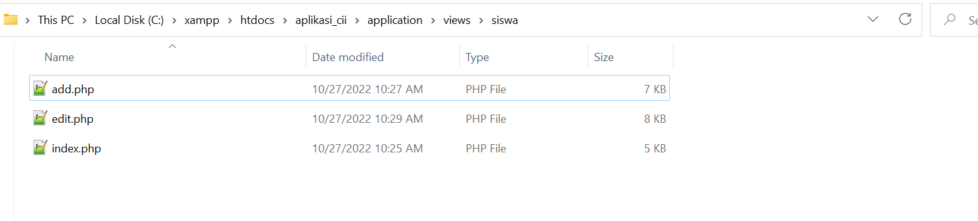

**Selamat Mencoba**